H.T No
Regulations:
A20

Sreenidhi Institute of Science and Technology
(An Autonomous Institution)
Code No: 8K201 Date: 13-Sept-2021 (FN)

B.Tech I-Year II- Semester External Examination, Sept-2021 (Regular)
ENGINEERING MECHANICS FOR CIVIL ENGINEERING (CIVIL)
Time: 3 Hours Max.Marks:70

Note: a) No additional answer sheets will be provided.
b) All sub-parts of a question must be answered at one place only, otherwise it will not be valued.
c) Missing data can be assumed suitably.

ANSWER ANY 5 OUT OF 8 QUESTIONS. EACH QUESTION CARRIES 14 MARKS.

Bloom's Cognitive Levels of Learning (BCLL)

Remember | L1 | Apply | L3 | Evaluate | L5
Understand | L2 | Analyze | L4 | Create | L6

 |  |  | BCLL | CO(s) | Marks
1. |  | Cylinder 1 having dia 200mm and cylinder 2 having dia 300mm are placed as shown in figure if the cylinder weight 1 800N and cylinder B weight 1200N Determine the contact reactions at A,B,C,D  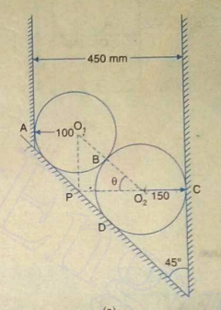 | L4 | CO1 | [14M]
2. |  | Determine the forces in the members of the truss using method of joints  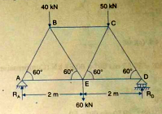 | L4 | CO2 | [14M]
3. |  | Calculate Moment of Inertia of given figure  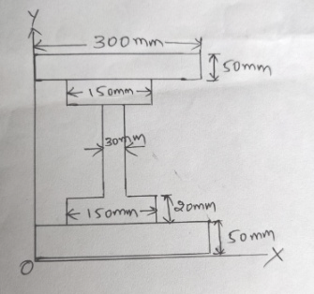 | L4 | CO3 | [14M]
4. |  | Determine the force in the member FH of the below given using Virtual work concept.  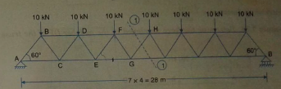 | L4 | CO4 | [14M]
5. | a) | Motion of particle is given as x= t³-3t²-9t+12. Determine the time and position, acceleration of particle when the velocity is 0m/s | L3 | CO5 | [7M]
 | b) | Body A thrown with velocity 20m/s at angel of 45 degrees. if the another body B is thrown at angel of 30 degrees to the horizontal. find out velocity of projectile B if the both Body A and B Having the  same horizontal range and same time of flight | L5 | CO5 | [7M]
6. | a) | Explain D’Alembert’s principle and its applications | L2 | CO6 | [7M]
 | b) | Two blocks A and B are held on an inclined plane SM apart as shown in figure below Figure co-efficient of friction b/w block A and Block B and the inclined planes are 0.2 and 0.1 respectively. If the blocks are began to slide down the plane simultaneously calculate time and distance travelled by each block before collision.  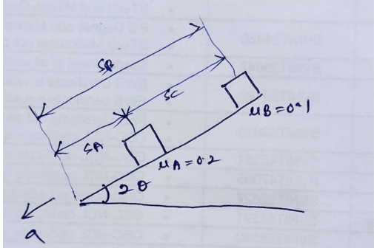 | L4 | CO6 | [7M]
7. | a) | A system of four forces acting on a body is shown in figure. Determine the resultant force and its direction.  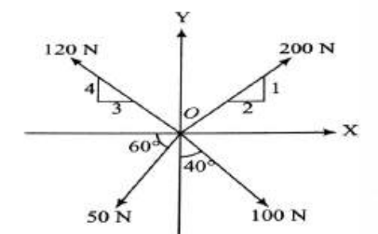 | L3 | CO1 | [7M]
 | b) | Explain about static friction and dynamic friction | L2 | CO2 | [7M]
8. |  | Determine the Wb using principal of virtual work for given beam .Friction between block A and plane is 0.3  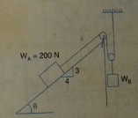 | L4 | CO4 | [14M]
-- 00 -- 00 –

